Results from YEAR Open Science survey 2016 (preliminary evaluation) – 2016-09-16
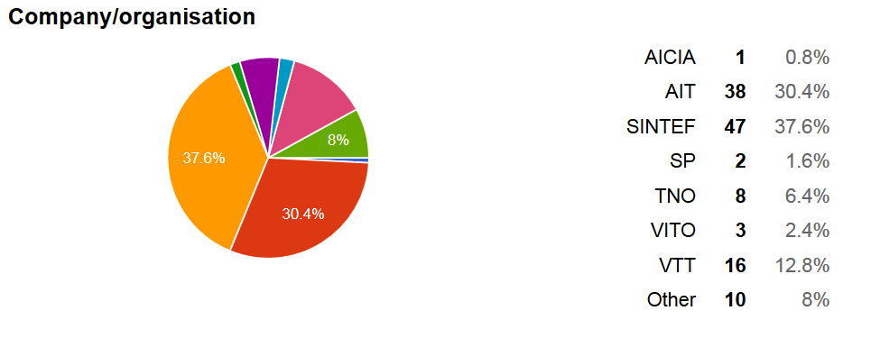 |  | Total number of respondents: 125  YEAR Network  Various Universities (EU, Africa), OpenCon community, individual, N/A
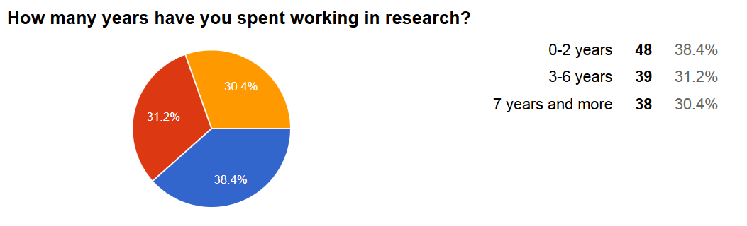 |  | 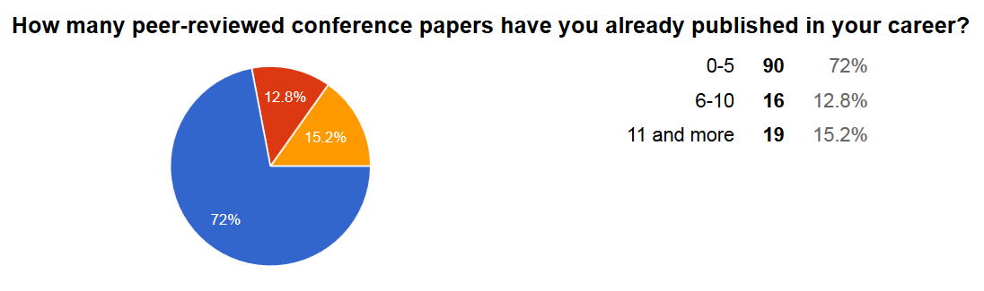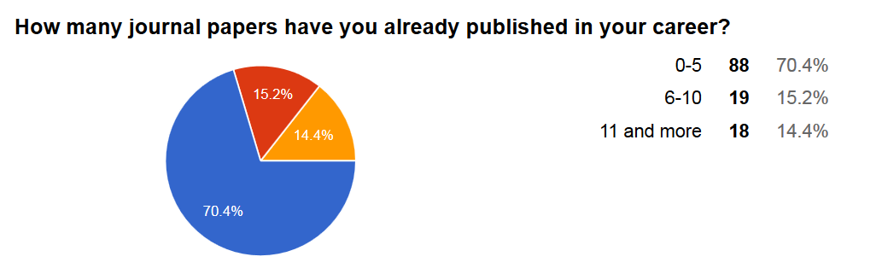
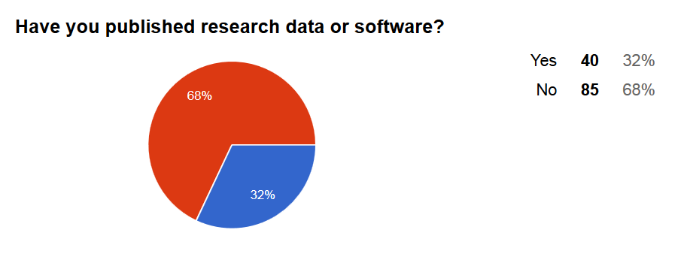 |  | Do you publish any other content or media about your research work?  Yes 39 31%  No 76 61%  Not yet 4 3%  Not often / Sometimes 2 2%  N/A 4 3%
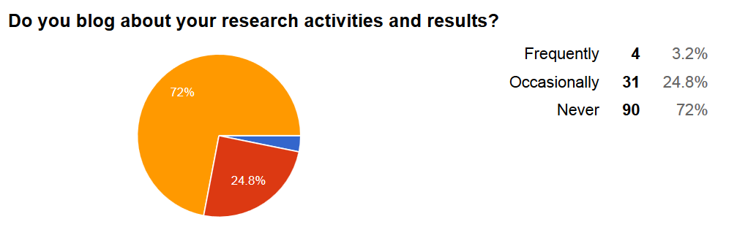 | 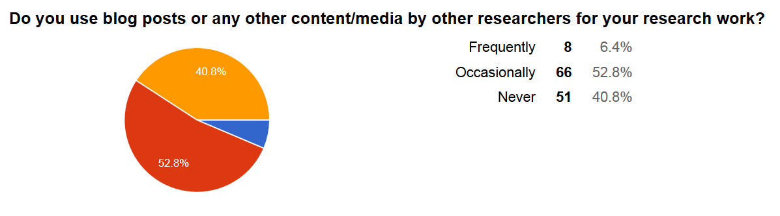
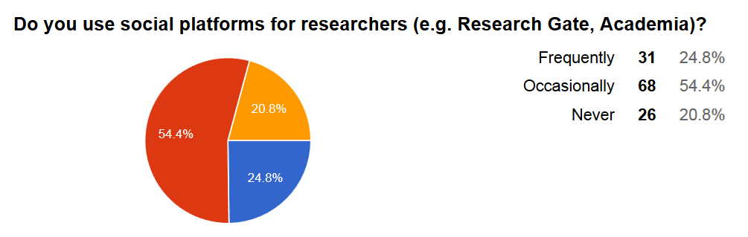
Where do you see the most important shortcomings of the current science system?

Restricted access to and delayed dissemination of scholarly results limit knowledge transfer to researchers and other members of society. | I totally agree | 66 | 53% | Scholarly communication is constrained by current reward structures favouring publication of research results in renowned academic publishing venues. | I totally agree | 56 | 45%
 | I partially agree | 43 | 35% |  | I partially agree | 39 | 31%
 | I partially disagree | 9 | 7% |  | I partially disagree | 13 | 10%
 | I totally disagree | 3 | 2% |  | I totally disagree | 4 | 3%
 | I don't know | 4 | 3% |  | I don't know | 13 | 10%
Many research results cannot be reproduced due to lack of underlying data, process instructions and context information. | I totally agree | 61 | 49% | The possibilities of digital technologies are not fully exploited in scholarly communication. | I totally agree | 41 | 33%
 | I partially agree | 39 | 31% |  | I partially agree | 55 | 44%
 | I partially disagree | 10 | 8% |  | I partially disagree | 17 | 14%
 | I totally disagree | 5 | 4% |  | I totally disagree | 4 | 3%
 | I don't know | 10 | 8% |  | I don't know | 8 | 6%
The quantity of research output is often valued over its quality. | I totally agree | 58 | 46% | Efficiently and effectively identify research that is relevant for my own research is demanding. | I totally agree | 40 | 32%
 | I partially agree | 44 | 35% |  | I partially agree | 48 | 38%
 | I partially disagree | 12 | 10% |  | I partially disagree | 22 | 18%
 | I totally disagree | 1 | 1% |  | I totally disagree | 7 | 6%
 | I don't know | 10 | 8% |  | I don't know | 8 | 6%

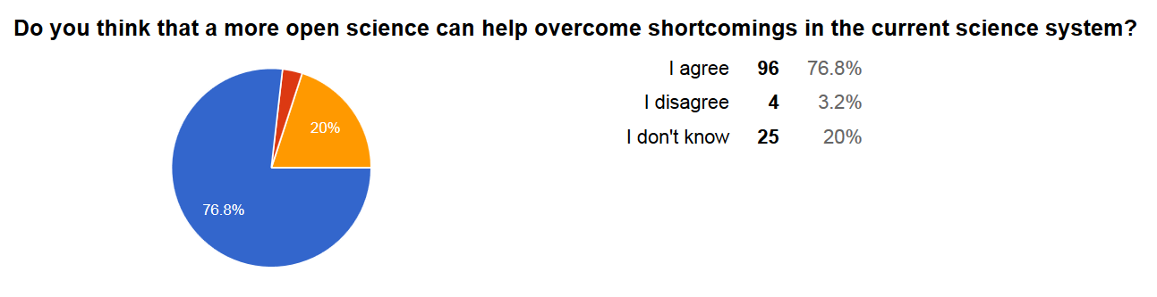
How would you prioritise the following policy actions supporting the transition to a more open science?

High priority |  |  |  | Low priority
Provide incentives to make scientific work openly available as early as possible | High priority | 97 | 77.6% | Organise debates at national and European levels to raise awareness and support take-up of Open Science | High priority | 43 | 34.4%
 | Low priority | 21 | 16.8% |  | Low priority | 70 | 56%
 | I don’t know | 7 | 5.6% |  | I don’t know | 12 | 9.6%
Provide support for spreading good/best practices for a better knowledge circulation within science and society | High priority | 85 | 68% | Increase expertise and guidance to improve e-skills amongst researchers and professional supporters (librarians, repository managers, etc.) | High priority | 50 | 40%
 | Low priority | 31 | 24.8% |  | Low priority | 63 | 50.4%
 | I don’t know | 9 | 7.2% |  | I don’t know | 12 | 9.6%
Reward researchers engaged in Open Science activities (career development)  Providing incentives and support for spreading scientific work openly, and for spreading good practices for knowledge circulation are clearly identified as a top priority.  It is essential to address those aspects to clarify confusions about Open Science, and to raise the researchers’ awareness of the benefits of Open Science practices. | High priority | 74 | 59.2%
 | Low priority | 39 | 31.2%
 | I don’t know | 12 | 9.6%
Promote a discussion on evaluation criteria of research | High priority | 74 | 59.2%
 | Low priority | 43 | 34.4%
 | I don’t know | 8 | 6.4%
Experiment with more open and transparent peer-review | High priority | 74 | 59.2%
 | Low priority | 38 | 30.4%
 | I don’t know | 13 | 10.4%

Preliminary conclusions (including a selection of additional comments by the survey participants in italic)

For the surveyed young researchers open science has huge potential. | - The majority agrees that open science can help overcome shortcomings in the current science system.
However only a minority of the surveyed young researchers has already adopted open science practices (our survey from 2014 showed a similar result). | - The majority is currently not publishing research data, software, or any other content besides conference and journal papers.  - The majority does not blog about their own research activities and results. About half of the surveyed young researchers does use blog posts or any other content/media by other researchers.  - About half of the surveyed young researchers occasionally make use of social platforms for researchers.
There are some barriers that should be tackled and aspects that should be considered when defining concrete policy actions. Policy actions at EU and national levels shall be absolutely clear, logical and fair to the researchers, the institutions and the industry partners. | - Current approach to open science is not well organized and challenging. […]  - […] Publication in open science is required by EU for funded projects, but still complex and difficult for industrial partners. […]  - […] many of the proposed changes [on policy level] can be seen critically.  - […] just make all the journals free and accessible to everyone... Universities have paid to make the research, to publish the papers, why should they pay again to have access to them? […]
Especially in the context of open research data some of the young researchers expressed their concern, in particular in context of research projects involving private companies. It is recommended to consider and involve all stakeholders in the open science policy development process. | - Europe should be careful not to play open cards while the rest of the world shields of their hand. Such a situation could result in leading European companies to retreat from collaborative research.  - For small companies open innovation doesn't work - if they give away their ideas to bigger competitors they are done.[…]  - It would be more prudent to allow organization data accessible freely to RELEVANT professionals and student. Because data forms a backbone of any research.
Open science challenges in terms of quantity of research output. | - the only doubt that I have with open science is the 'findability'. It is now already hard to find the right article. With open science I can imagine it will be even harder.  - Improve search engines: finding relevant research results and databases is very difficult because of poor search engines
Open science challenges in terms of quality of research output. | - The idea of open science is good, but scholarly publication has to always be at an expert level. […] Creating open science specifically to open the research to all stakeholders might therefore lead to presenting work for the level of the stakeholder who has the most superficial scientific interest, and therefore will not help the quality or the robustness of scientific work overall.  - Having a peer review system similar to Wikipedia where one can look up how a paper evolved and who contributed (also the reviewers) would lead to faster progress (everyone can review), more openess and possibly better reviews.

